ORDER
OF THE
HOLY MASS
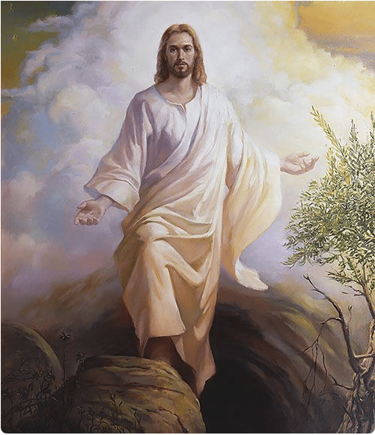
Season of Easter
“Theme”

______ Sunday of Easter
MM DD, 20YY

Processional
Please stand

Selection per Parish or Mission
Acclamation
The Ministers face the Presider, while the Presider faces the people and proclaims:
Presider: Hallelujah! Christ is risen!
People: The Lord is risen indeed! Hallelujah!
Collect for Purity
Presider: Let us pray.
Clergy face the Altar. Miter off.
Almighty God, to You all hearts are open,
all desires known, and from You no secrets are hid.
Cleanse the thoughts of our hearts ✠
by the inspiration of Your Holy Spirit,
that we may perfectly love You
and worthily magnify Your holy Name;
through Christ our Lord.

All: Amen.

Penitential Rite
The Summary of the Law and the Invitation to Confession are spoken by the Deacon in a high mass.
Deacon faces the people.
Summary of the Law
Deacon: Jesus said, “The first Commandment is this:
Hear, O Israel: the Lord our God, the Lord is one. Love the Lord Your God with all your heart, with all your soul, with all your mind, and with all your strength.
The second is this: Love your neighbor as yourself. There is no other commandment greater than these.
Deacon: Dearly beloved, let us come into the presence of the Almighty God, praying together as we kneel:
Deacon faces the Altar. All kneel. Deacon leads the prayer, in unison:
Confession
All: Most merciful God, I confess that I have sinned against You in thought, word, and deed, by what I have done, and by what I have left undone. I have not loved You with my whole heart; I have not loved my neighbor as myself. I am truly sorry and I humbly repent. For the sake of Your Son Jesus Christ, have mercy on me and forgive me; that I may delight in Your will, and walk in Your ways, to the glory of Your Name. Amen.

Absolution
Presider faces the people.
Presider: Almighty God have mercy on you, ✠ forgive you all your sins through our Lord Jesus Christ, strengthen you in all goodness, and by the power of the Holy Spirit keep you in eternal life.
All: Amen.
Please stand

Glory in the Highest (Gloria in Excelsis)
The Presider censes the Altar and then the Deacon of the Mass censes the Ministers.
Arrangement per parish or mission
Collect of the Day ____ Sunday of Easter CEC
Presider faces the people.
Presider: The Lord be with you.
People: And with your spirit.
Presider: Let us pray.
Presider and Ministers face the Altar.
The Collect of the Day is taken from the designated Proper.

Presider: According to designated Proper

All: Amen.
Presider goes to the back of the Altar, kisses it, and goes to his chair.
Please be seated

Liturgy of the Word
Please be seated
First Proclamation
Proclaimer: A Proclamation of the Word of God from …

According to the designated Proper

Proclaimer: The Word of the Lord.
People: Thanks be to God!

Responsorial Psalm:
According to the designated Proper

Proclaimer: Please stand for the Responsorial Psalm, which
- today is … (if the entire psalm is read)
- is taken from … (if only a portion of the psalm is read)

All stand and the Proclaimer leads the people in the Responsorial Psalm followed by the Gloria Patri.
Gloria Patri (BCP, Rite II)
The Gloria Patri may be spoken or sung in unison. The Proclaimer and Altar Ministers remain in their places, face the Altar, and bow.
All: Glory to the Father, and to the Son, and to the Holy Spirit: ✠
As it was in the beginning, is now, and will be forever. Amen.
A Choral Response may be sung here.

Selection per Parish or Mission

Please be seated.
Please be seated
Second Proclamation
Proclaimer: A Proclamation of the Word of God from …
According to the designated Proper
The proclaimer reads the second appointed lesson of the day.
Proclaimer: The Word of the Lord.
People: Thanks be to God!
Please stand.
Gradual Verse
Proclaimer: According to the designated Proper

Miter On. Bless the Gospel Proclaimer.
Gradual Hymn

Selection per Parish or Mission

Gospel Acclamation
Miter Off.
Deacon: The Lord be with you.
People: And with your spirit.
Deacon: May the Lord be on our ✠ minds, on our ✠ lips, and on our ✠ hearts as we hear ✠ His Holy Gospel.
The Holy Gospel of our Lord Jesus Christ according to Saint ….
People: Glory to You, Lord Christ!

Gospel Proclamation
The appointed Gospel is read by a Deacon.
According to the designated Proper

Deacon: The Gospel of the Lord.
People: Praise to You, Lord Christ!
All sit.
Homily
Please stand

Nicene Creed
All: We believe in one God, the Father Almighty, Maker of Heaven and earth, and of all things: visible and invisible.
And in one Lord, Jesus Christ, the only begotten Son of God, begotten of His Father before all worlds;
God of God, Light of Light, very God of very God
begotten, not made, being of one substance with the Father;
by Whom all things were made;
Who for us men and for our salvation came down from Heaven;
and was incarnate by the Holy Spirit and the Virgin Mary, and was made man;
And was crucified also for us under Pontius Pilate;
He suffered death and was buried, and rose again on the third day, in accordance with the Scriptures;
and ascended into Heaven, and is seated on the right hand of the Father;
and He shall come again, with glory, to judge the living and the dead;
Whose Kingdom shall have no end.
And we believe in the Holy Spirit the Lord, and Giver of Life, Who proceeds from the Father;
Who with the Father and the Son together is worshiped and glorified;
Who has spoken through the prophets.
And we believe one holy catholic and apostolic Church;
We acknowledge one baptism for the remission of sins;
and we look for the resurrection of the dead, and the life of the world to come. Amen. ✠

Prayers of the People Form VII (Made from directions in BCP)
The Deacon begins the Prayers of the People. The Minister continues.
Deacon: Let us pray for the whole state of Christ’s Church, and for the world.
Minister: Almighty Father, we lift before You Your holy catholic Church:
People: That You would lead us in truth, baptize us in love, and unite us in spirit.
Minister: We pray for her leaders, especially Bishop Craig and Bishop Ariel:
People: That they may with one voice minister Your life to Your people and the world.
Minister: We lift before You the people of this community, this nation, and the world:
People: That we may honor one another and serve the common good.
Minister: We pray for our governmental leaders, especially President Duterte:
People: That You would lead them in the ways of justice and peace.
Minister: We lift before You all who suffer in body, mind, or spirit:
People: That You would send Your comfort and grace upon them.
Minister: Give to the departed eternal rest:
People: Grant that we may share with them in Your everlasting Kingdom.

Presider: We lift to You the people of this parish:
People: As we pray the Corporate Petition.

Corporate Petition
Almighty God and King,
our dwelling place in all generations,
owner of the earth and all it contains:
Grant unto us our allotted inheritance, we pray,
and the grace to build upon it
facilities in which Your people,
being restored in Your image
and ever-growing in love for You,
might become a habitation of Your presence
and ministers of Your life,
to the glory of Jesus Christ our Lord;
Who lives and reigns together with You
and the Holy Spirit, one God,
now and forever. Amen.

Alternatively, the Prayers of the Faithful included in the Proper for this Sunday or other feast may be prayed instead.

Refer to the Proper provided.

On April 24, May 1, and May 8, include the following prayer:

Prayer over an Election
All: O Lord our Governor, in Your perfect kingdom no sword is drawn but the sword of righteousness, no strength known but the strength of love. Yet every authority is from you, including those who must from time to time bear the sword; and we must account for all our powers and privileges in electing these public servants. So guide, we pray, the people of the Republic of the Philippines in the upcoming elections of officials and representatives; that we may choose and support candidates not according to our personal prejudices and welfare, but according to the direction we prayerfully receive from You. Grant that, by faithful administration and wise laws, the rights of all may be protected and our nation be enabled to fulfill Your purposes; and mightily spread abroad Your Holy Spirit, that all peoples may be gathered under the banner of the Prince of Peace, as children of one Father; to Whom be dominion and glory, now and forever. Amen.

Concluding Collect

Presider: According to the designated Proper
All: Amen.

Peace

Presider: The peace of the Lord be always with you.

People: And with your spirit.
Presider: Let us offer one another a sign of God’s peace.

Offertory
Presider gives the Offering Exhortation.

Worship in Psalms,
Hymns,
and Spiritual Songs:
The Sacrifice
of Praise

The Offertory:
The Sacrifice
of Ourselves

Selection per parish or mission
The Lesser Doxology may be sung in a high mass, during which time the Presider censes the gifts.
After the Altar and Gifts have been censes by the Presider, the Deacon censes the Ministers, then all of the people.
Then Presider censes the front of the Altar and the Ministers again.

Lesser Doxology
(Traditional)
(Words and Music by: Thomas Ken)
(Attributed to Louis Bourgeois)

Praise God from Whom all blessings flow,
Praise Him all creatures here below;
Praise Him above, ye heavenly Host:
Praise Father, Son and Holy Ghost!
AMEN!

Preparation of the Gifts
Standing behind the Altar, the Presider takes the paten with the bread or a large host, and, holding it slightly raised above the altar, says:
Presider: Blessed are You Lord, God of all creation. For through Your goodness we have received the bread we offer You: fruit of the earth and work of human hands, it will become the Body of Christ.
People: Blessed be God forever.
While pouring a small amount of water into the chalice and flagon, the Presider says quietly:
Presider: By the mystery of this water and wine may we come to share in the divinity of Christ, who humbled Himself to share in our humanity.
Then the Presider takes the chalice and, holding it slightly raised above the altar, says:
Presider: Blessed are You Lord, God of all creation, for through Your goodness we have received the wine we offer You, fruit of the vine and work of human hands; it will become the Blood of Christ.
People: Blessed be God forever.

Then the Presider takes an offering basket or bag, and while holding it slightly raised above the altar, says:
Presider: Blessed are You Lord, God of all creation, for through Your goodness we bring these tithes and offerings before You. They will be used in Your church for the work You have set before us and the furthering of Your kingdom.
Presider places the offering below the altar, then washes his hands, quietly saying:
Presider: Wash me, O Lord, from my iniquity and cleanse me from my sin.
Exhortation To Pray (Orate fratres)
The Presider returns to the center of the altar, faces the people, and says:
Presider: Pray, brothers and sisters, that our sacrifice may be acceptable to God, the Almighty Father.
People: May the Lord accept the sacrifice at your hands for the praise and glory of His name, for our good and the good of all His holy Church.
All: Amen.

Great Thanksgiving
Presider: The Lord be with you.
People: And with your spirit.
Presider: Lift up your hearts.
People: We lift them up to the Lord.
Presider: Let us give thanks to the Lord our God.
People: It is right to give Him thanks and praise.
Preface Easter CEC
The priest continues the preface with hands extended:
Presider: According to the designated Proper

Sanctus Benedictus

Eucharistic Prayer VIII CEC
The presider, with hands extended, says:
Presider: We give You praise, Father most holy, for You are great and You have fashioned all Your works in wisdom and in love. You formed man in Your own image and entrusted the whole world to his care, so that in serving You alone, the Creator, He might have dominion over all creatures.
And when through disobedience he had lost Your fellowship, You did not abandon him to the domain of death. For You came in mercy to the aid of all, so that those who seek might find You. Time and again You offered covenant with man, and through the prophets taught him to look forward to salvation.
And You so loved the world, Father most holy, that in the fullness of time You sent Your only begotten Son to be our Savior. Made incarnate by the Holy Spirit and born of the Virgin Mary, He shared our human nature in all things but sin. To the poor He proclaimed the good news of salvation, to prisoners, freedom, and to the sorrowful of heart, joy. To accomplish Your plan, He gave himself up to death, and rising from the dead, He destroyed death and restored life.

Presider: And that we might live no longer for ourselves, but for Him who died and rose again for us, You sent the Holy Spirit, Father, as the first fruits for those who believe, so that, bringing to perfection His work in the world, He might sanctify creation to the full.
Please kneel.
Invocation of the Holy Spirit
The Presider raises his hands above the Altar, then lowers them down above the offerings. While making the sign of the cross once over both the bread and chalice, he says:
Presider: Therefore, O Lord, we pray: may this same Holy Spirit graciously sanctify these ✠ offerings, that they may become the Body and Blood of our Lord Jesus Christ, for the celebration of this great mystery, which He himself left us as an eternal covenant.
The Presider joins his hands.

Words of Institution
The words of the Lord in the following formulas should be spoken clearly and distinctly, as their meaning demands.
Presider: For when the hour had come for Him to be glorified by You, Father most holy, having loved His own who were in the world, He loved them to the end. And while they were at supper He took bread, blessed and broke it, and gave it to His disciples, saying:
“Take, eat: This is My Body, which is given for you. Do this for the remembrance of Me.”
The Presider shows the consecrated host to the people, places it on the paten, and bows or genuflects in adoration.
The Presider continues:
Presider: In a similar way, taking the cup filled with the fruit of the vine, He gave thanks and gave the cup to His disciples, saying:
“Drink this, all of you: This is My Blood of the New Covenant, which is shed for you and for many for the forgiveness of sins. Whenever you drink it, do this for the remembrance of Me.”
The Presider shows the consecrated chalice to the people, places it on the corporal, and bows or genuflects in adoration.
Please stand.

Please stand.
Mystery of Faith
Then, with hands extended, the Presider says:
Presider: Let us proclaim the mystery of faith:
Then all sing or say:
All: Christ has died,
Christ is risen,
Christ will come again.

Prayer for the Church
Then with hands extended, the Presider says:
Presider: Therefore, O Lord, as we now celebrate the memorial of our redemption, we remember Christ’s death and His descent to the realm of the dead. We proclaim His resurrection and His ascension to Your right hand, and, as we await His coming in glory, we offer You His Body and Blood.
Look, O Lord, upon the sacrifice of praise and thanksgiving which You Yourself have provided for Your church, and grant in Your loving kindness to all who partake of this one bread and one cup that, gathered into one body by the Holy Spirit, they may truly become a living sacrifice in Christ to the praise of Your glory.

Presider: Therefore, Lord, remember now your servants Craig our Patriarch, Ariel our Bishop, and the whole order of Bishops. Remember all the clergy, especially those who take part in the offering, as well as your people gathered here before you, seeking you with sincere hearts.
The Presider prays for them briefly with hands joined. Then, with hands extended, he continues:
Presider: To all of us, Your children, grant, O merciful Father, that we may enter into a heavenly inheritance with the Blessed Virgin Mary, Mother of God, and with Your apostles and saints in Your kingdom. There, with the whole of creation freed from the corruption of sin and death, may we glorify You through Christ our Lord,
The Presider joins his hands.
through whom You bestow on the world all that is good.

Great Doxology and Great Amen
The Presider takes the chalice and the host, and lifting them up, says:
Presider: By Him, with Him, and in Him, in the unity of the Holy Spirit, all honor and glory is Yours, Almighty Father, now and forever.
The people respond:
People: AMEN.
The Lord’s Prayer
The Presider continues:
Presider: And now as our Savior Christ taught us, we are bold to pray.
THE LORD’S PRAYER

Our Father, Who art in heaven,
Hallowed be Thy Name;
Thy kingdom come;
Thy will be done on earth as it is in heaven.
Give us this day our daily bread.
And forgive us our trespasses,
As we forgive those who trespass against us.
And lead us not into temptation,
But deliver us from evil.
For Thine is the Kingdom, and the power,
And the glory; forever, and ever.
AMEN. ✠

Breaking of the Bread
The Presider breaks the consecrated host in half, then breaks off a small piece and places it in the chalice.
Christ our Passover (Pascha Nostrum)
The Christ our Passover (Pascha Nostrum) may be spoken or sung in unison, or antiphonally by the Presider and the People.
Presider: Hallelujah!
Christ our Passover is sacrificed for us!
People: Therefore, let us keep the feast. Hallelujah!
- or – Pascha Nostrum
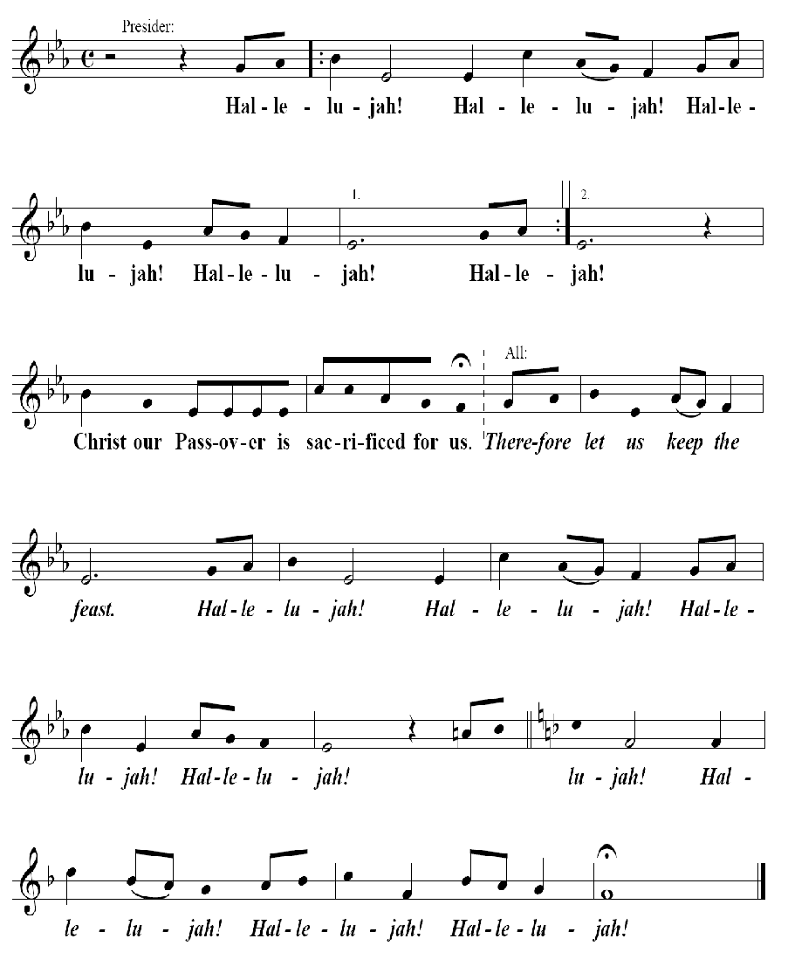

Invitation to Communion
The Presider elevates the host and the chalice together, saying:
Presider: Behold the Lamb of God, behold Him Who takes away the sin of the world. Blessed are those called to the Supper of the Lamb.
People: Lord, I am not worthy that You should enter under my roof, but say only the word and my soul shall be healed.
Presider: The gifts of God for the people of God:
Take them in remembrance that Jesus died for you, and feed on Him in your hearts with thanksgiving.

Prayer for Receiving Spiritual Communion
(for streaming screen only)
All: My Jesus, I believe that You are present in the Most Holy Sacrament. I love You above all things, and I desire to receive You into my soul.

Since I cannot at this moment receive You sacramentally, come at least spiritually into my heart. I embrace You as if You are already there, and unite myself wholly to You. Never permit me to be separated from You. Amen.

The Ministration of Communion

Selection per parish or mission

Post-Communion Prayer
Presider: Let us pray.
All: Almighty and everliving God, we thank You for feeding us with the spiritual food of the most precious Body and Blood of Your Son, our Savior Jesus Christ; and for assuring us in these holy mysteries that we are living members of the Body of Your Son, and heirs of Your eternal kingdom.
And now, Father, send us out to do the work You have given us to do, to love and serve You as faithful witnesses of Christ our Lord.
To him, to You, and to the Holy Spirit, be honor and glory, now and forever. Amen.
Blessing
Miter on.
Bishop: The Lord be with you.
People: And with your spirit.
Bishop: Our help is in the Name of the Lord.
People: The maker of heaven and earth.

Deacon: Bow your heads and pray for God’s blessing.
Bishop: May the God of peace, Who brought again from the dead our Lord Jesus Christ, the Great Shepherd of the sheep, through the Blood of the everlasting Covenant, make you perfect in every good work to do His will, working in you that which is well-pleasing in His sight;

and the blessing of God Almighty: ✠ the Father and the Son and the Holy Spirit, be with you now and forever. Amen.

Recessional
Selection per parish or mission.
Dismissal
Deacon: Go in peace glorifying the Lord by your life.
People: Thanks be to God. Hallelujah! Hallelujah! Amen. ✠

