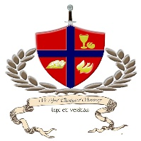
International Communion of the
Charismatic Episcopal Church
Diocese of Northern Mindanao, Diocese of Southern Luzon
St. Cyril Theological Seminary

CALENDAR
(For The First Semester of the Academic Year 2020, Diocese of the NCR Class)
WEEK | DATE | ACTIVITY
 | February 11 | Orientation
 | February 17 – 21 | Opening of Class
 | February 24 – 28
 | March 2 – 6
 | March 9 – 13
 | March 16 – 20
 | March 23 – 27
 | March 30 – April 3
 | April 6 – 10 | Holy Week
 | April 13 – 17
 | April 20 – 24 | Mid Terms
 | April 27 – May 1
 | May 4 – 8
 | May 11 – 15 | On Site Class NCR
 | May 18 – 22
 | May 25 – 29
 | June 1 – June 5
 | June 8 – 12
 | June 15 – 19
 | June 22 – 26 | On Site Class NCR
 | June 29 – July 3 | FINALS

* For submissions of papers and other academic requirements, please refer to the course syllabus.

Please find the academic calendar for First Semester AY2020

Please note of the following important dates:

January 16 - 31 - Enrollment for the Second Semester
February 5 - 9 - Opening Week

February 7, Wednesday- First On-Line Class , Batch 2
February 8, Thursday - First On-Line Class , Batch 1

March, 2018 - on-site Class with Fr.Jay

June 22 - Finals

~jay+

