Seven Last Words of Christ
The Solemn Prayers
Veneration of the Cross
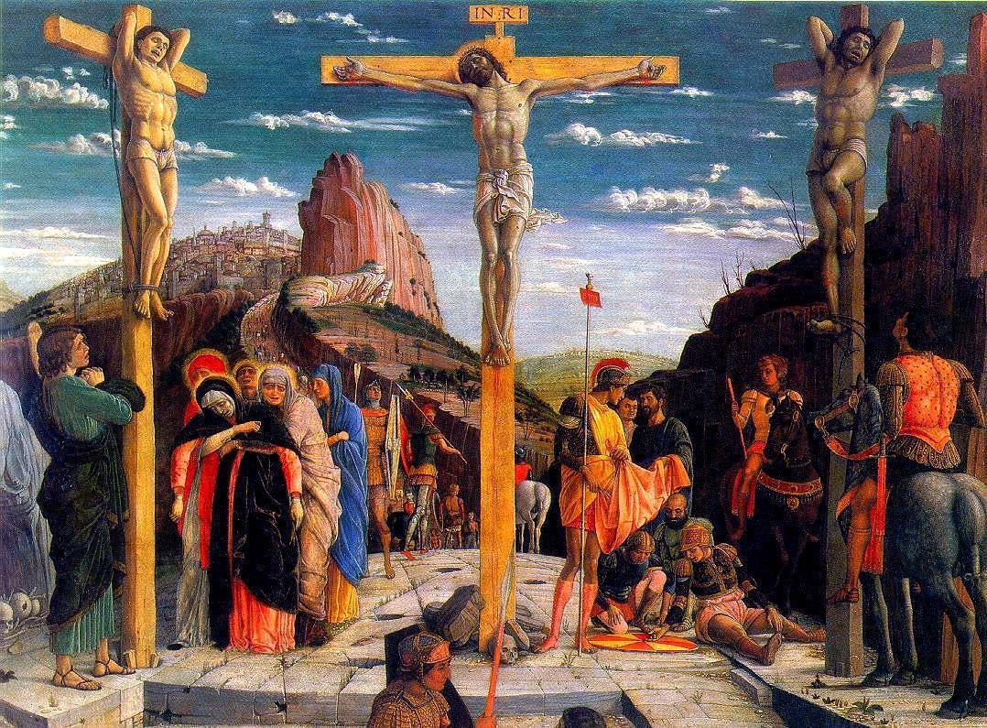
Good Friday
Mass of the Pre-sanctified
April 7, 2023

The Way Of The Cross

Please stand
Minister’s Entrance

Presider: In the Name of the Father, and of the Son, and of the Holy Spirit.
People: Amen.
Presider: Let us pray.

Face Altar
Lord Jesus Christ, for our sake You became like the grain of wheat that falls to the earth and dies, so that it may bear much fruit. You have invited us to take up our own crosses and follow You along this path, and further said that “Those who love their life will lose it, and those who hate their life in this world will keep it for eternal life.”

Grant us this day, as we walk with You on the Way of the Cross, a revelation of what Your Cross meant to You, and what our Cross means to us. Grant us today the grace of contemplation, in Your Name we pray.

All: Amen.

Bishop goes to pulpit

The Seven Last Words Of Christ

A Musical Offering From the Holy Society of King David:
“xxx” xxx

First Word

“Father, forgive them; for they know not what they do.” (Luke 23: 34)

Presider : And when they came to the place called the Skull, there they crucified Him. But Jesus was saying, “Father, forgive them; for they do not know what they are doing.”

The First Word: A Musical Offering
From the Holy Society of King David

The Extinguishing of the First Candle

Reflection

Second Word

“Verily, thou shalt be in Paradise today with Me.” (Luke 23: 43)

Presider : And they crucified Him with two criminals, one on the right and the other on the left. And one of the criminals who were hanged there was hurling abuse at Him, saying, “Are You not the Christ? Save Yourself and us!”

But the other answered, and rebuking him said, “Do you not even fear God, since you are under the same sentence of condemnation? And we indeed justly, for we are receiving what we deserve for our deeds; but this man has done nothing wrong.”

And he was saying, “Jesus, remember me when You come into Your Kingdom!” And He said to him, “Truly I say to you, today you shall be with Me in Paradise.”

The Second Word: A Musical Offering
From the Holy Society of King David

The Extinguishing of the Second Candle

Reflection

Third Word

“See, O Woman! Here behold thy son beloved.” (John 19: 26)

Presider : But there were standing by the Cross of Jesus His mother, and His mother’s sister, Mary the wife of Clopas, and Mary Magdalene. When Jesus therefore saw His mother, and the disciple whom He loved standing nearby, He said to His mother, “Woman, behold your son!” Then He said to the disciple, “Behold your mother!”

And from that hour the disciple took her into his own household.

The Third Word: A Musical Offering
From the Holy Society of King David

The Extinguishing of the Third Candle

Reflection

Fourth Word

“God, My Father, Why hast Thou forsaken Me?” (Matthew 27: 46)

Presider : Now from the sixth hour darkness fell upon all the land until the ninth hour. And about the ninth hour Jesus cried out with a loud voice, saying, “Eli, Eli, lama Sabachthani?” that is, “My God, My God, why hast Thou forsaken Me?”

The Fourth Word: A Musical Offering
From the Holy Society of King David

The Extinguishing of the Fourth Candle

Reflection

Fifth Word

“I am athirst.” (John 19: 28)

Presider : After this Jesus, knowing that all things had already been accomplished, in order that the Scripture might be fulfilled, said, “I am thirsty.” A jar full of sour wine was standing there; so they put a sponge full of the sour wine upon a branch of hyssop, and brought it up to His mouth.

The Fifth Word: A Musical Offering
From the Holy Society of King David

The Extinguishing of the Fifth Candle

Reflection

Sixth Word

“It is finished!” (John 19: 30)
Presider : When Jesus therefore had received the sour wine, He said, “It is finished!” And He bowed His head, and gave up His spirit.

A Musical Offering
From the Holy Society of King David

The Extinguishing of the Sixth Candle

Reflection

Seventh Word

“Father, into Thy hands I commit My soul.”
(Luke 23: 46)

Presider : And darkness fell over the whole land until about the ninth hour, the sun being obscured; and Jesus, crying out with a loud voice, said, “Father, into Thy hands I commit My Spirit.”

The Seventh Word: A Musical Offering
From the Holy Society of King David

The Extinguishing of the Seventh Candle

Reflection

(Miter on)
Removal of the Christ Candle

The Deacon removes the Christ Candle

Strepitus

The Bishop stamps his crozier three times; a noise from the sound board could augment this action

The Deacon replaces the Christ Candle, please stand

Solemn Prayers

The Bishop’s unit goes up to the Altar, faces the people

Deacon: Dear people of God: Our heavenly Father sent His Son into the world, not to condemn the world, but that the world through Him might be saved; that all who believe in Him might be delivered from the power of sin and death, and become heirs with Him of everlasting life.

We pray, therefore, for people everywhere according to their needs, devoutly kneeling.

All except Bishop’s Unit kneel

Deacon: Let us pray, dearly beloved, for the holy Church of God, that our God and Lord be pleased to give her peace, to guard her and to unite her throughout the whole world and to grant that, leading our lives in tranquility and quiet, we may glorify God the Father Almighty.

A time of silent prayer by all

Presider: Almighty ever-living God, Who in Christ revealed Your glory to all the nations, watch over the works of Your mercy, that Your Church, spread throughout all the world, may persevere with steadfast faith in confessing Your Name; through Christ our Lord. Amen.

Deacon: Let us pray also for our patriarch Craig Bates, that our God and Lord, Who chose him for the Order of Bishops, may keep him safe and unharmed for the Lord’s holy Church, to govern the holy People of God.

A time of silent prayer by all

Presider: Almighty ever-living God, by Whose decree all things are founded, look with favor on our prayers and in Your kindness protect the man chosen for us; also the pope and all other Christian leaders, that, under them, the Christian people, governed by You their maker, may grow in merit by reason of their faith; through Christ our Lord. Amen.
Deacon: Let us pray also for Bishop Ariel, for all Bishops, Priests, and Deacons of the Church, and for the whole of the faithful people.

A time of silent prayer by all

Presider: Almighty ever-living God, by Whose Spirit the whole body of the Church is sanctified and governed, hear our humble prayer for Your ministers, that, by the gift of Your grace, all may serve You faithfully; through Christ our Lord. Amen.

Deacon: Let us pray also for all catechumens, that our God and Lord may open wide the ears of their inmost hearts and unlock the gates of His mercy, that, having received forgiveness of all their sins through the waters of rebirth, they, too, may be one with Christ Jesus our Lord.

A time of silent prayer by all

Presider: Almighty ever-living God, Who makes Your Church ever fruitful with new offspring, increase the faith and understanding of the catechumate, that, reborn in the font of Baptism, they may be added to the number of Your adopted children; through Christ our Lord. Amen.

Deacon: Let us pray also for all our brothers and sisters who believe in Christ, that our God and Lord may be pleased, as they live the truth, to gather them together and keep them in His one Church.

A time of silent prayer by all

Presider: Almighty ever-living God, Who gathers what is scattered and keeps together what You have gathered, look kindly on the flock of Your Son, that those whom one Baptism has consecrated may be joined together by integrity of faith and union in the bond of charity; through Christ our Lord. Amen.

Deacon: Let us pray also for the Jewish people, to whom the Lord our God spoke first, that He may grant them to advance in love of His Name and in faithfulness to His covenant.

A time of silent prayer by all

Presider: Almighty ever-living God, who bestowed your promises on Abraham and his descendants, hear graciously the prayers of Your Church, that the people you first made your own may attain the fullness of redemption; through Christ our Lord. Amen.

Deacon: Let us pray also for those who do not believe in Christ, that, enlightened by the Holy Spirit,
they, too, may enter on the way of salvation.
A time of silent prayer by all

Presider: Almighty ever-living God, grant to those who do not confess Christ that, by walking before You with a sincere heart, they may find the truth and that we ourselves, being constant in mutual love and striving to understand more fully the mystery of Your life, may be made more perfect witnesses to Your love in the world; through Christ our Lord. Amen.

Deacon: Let us pray also for those who do not acknowledge God, that, following what is right in sincerity of heart, they may find the way to God Himself.
A time of silent prayer by all

Presider: Almighty ever-living God, Who created all people to seek You always by desiring You and, by finding You, come to rest, grant, we pray, that, despite every harmful obstacle, all may recognize the signs of Your fatherly love and the witness of the good works done by those who believe in You, and so in gladness confess You, the one true God and Father of our human race; through Christ our Lord. Amen.

Deacon: Let us pray those in public office, especially President Marcos, that our God and Lord may direct their minds and hearts according to His will for the true peace and freedom of all.

A time of silent prayer by all

Presider: Almighty ever-living God, in Whose hand lies every human heart and the rights of peoples: Look with favor, we pray, on those who govern with authority over us, that throughout the whole world the prosperity of peoples, the assurance of peace, and freedom of religion may through your gift be made secure; through Christ our Lord. Amen.

Deacon: Let us pray, dearly beloved, to God the Father almighty, that He may cleanse the world of all errors, banish disease, drive out hunger, unlock prisons, loosen fetters, uplift the downtrodden, grant safety to travelers, return to pilgrims, health to the sick, and salvation to the dying.

A time of silent prayer by all

Presider: Almighty ever-living God, comfort of mourners, strength of all who toil, may the prayers of those who cry out in any tribulation come before You,
that all may rejoice, because in their hour of need Your mercy was at hand; through Christ our Lord. Amen.

Deacon: Let us commit ourselves to God, and pray for the grace of a holy life, that, with all who have departed this world and have died in the peace of Christ, and with those whose faith is known to God alone, we may be accounted worthy to enter into the fullness of the joy of our Lord, and receive the crown of life in the day of resurrection.

A time of silent prayer by all

Presider: O God of unchangeable power and eternal light: Look favorably upon Your whole Church, that wonderful and sacred mystery; and by the tranquil operation of Your providence, carry out the work of man's salvation; let the whole world see and know that things which were cast down are being raised up, and things which had grown old are being made new, and that all things are being brought unto the perfection of Him through Whom all things were made, Your Son our Lord Jesus Christ; Who lives and reigns with You in the unity of the Holy Spirit, one God, forever and ever. Amen.

The Cross is brought out and set before the Altar. The Bishop and others appointed address the Good Friday Hymn to it.

Good Friday Hymn
All: Faithful Cross the Saints rely on,
Noble tree beyond compare!
Never was there such a scion,
Never leaf or flower so rare.
Sweet the timber, sweet the iron,
Sweet the burden that they bear!
Cantors: Sing, my tongue, in exultation
Of our banner and device!
Make a solemn proclamation
Of a triumph and its price:
How the Savior of creation
Conquered by his sacrifice!
All: Faithful Cross the Saints rely on,
Noble tree beyond compare!
Never was there such a scion,
Never leaf or flower so rare.
Cantors: For, when Adam first offended,
Eating that forbidden fruit,
Not all hopes of glory ended
With the serpent at the root:
Broken nature would be mended
By a second tree and shoot.
All: Sweet the timber, sweet the iron,
Sweet the burden that they bear!

Cantors: Thus the tempter was outwitted
By a wisdom deeper still:
Remedy and ailment fitted,
Means to cure and means to kill;
That the world might be acquitted,
Christ would do his Father’s will.

All: Faithful Cross the Saints rely on,
Noble tree beyond compare!
Never was there such a scion,
Never leaf or flower so rare.
Cantors: So the Father, out of pity
For our self-inflicted doom,
Sent him from the heavenly city
When the holy time had come:
He, the Son and the Almighty,
Took our flesh in Mary’s womb.
All: Sweet the timber, sweet the iron,
Sweet the burden that they bear!

Cantors: Hear a tiny baby crying,
Founder of the seas and strands;
See his virgin Mother tying
Cloth around his feet and hands;
Find him in a manger lying
Tightly wrapped in swaddling-bands!

All: Faithful Cross the Saints rely on,
Noble tree beyond compare!
Never was there such a scion,
Never leaf or flower so rare.
Cantors: So he came, the long-expected,
Not in glory, not to reign;
Only born to be rejected,
Choosing hunger, toil and pain,
Till the scaffold was erected
And the Paschal Lamb was slain.
All: Sweet the timber, sweet the iron,
Sweet the burden that they bear!
Cantors: No disgrace was too abhorrent:
Nailed and mocked and parched he died;
Blood and water, double warrant,
Issue from his wounded side,
Washing in a mighty torrent
Earth and stars and oceantide.

All: Faithful Cross the Saints rely on,
Noble tree beyond compare!
Never was there such a scion,
Never leaf or flower so rare.

Cantors: Lofty timber, smooth your roughness,
Flex your boughs for blossoming;
Let your fibers lose their toughness,
Gently let your tendrils cling;
Lay aside your native gruffness,
Clasp the body of your King!
All: Sweet the timber, sweet the iron,
Sweet the burden that they bear!

Cantors: Noblest tree of all created,
Richly jeweled and embossed:
Post by Lamb’s blood consecrated;
Spar that saves the tempest-tossed;
Scaffold-beam which, elevated,
Carries what the world has cost!
All: Faithful Cross the Saints rely on,
Noble tree beyond compare!
Never was there such a scion,
Never leaf or flower so rare.

All: Wisdom, power, and adoration
To the blessed Trinity
For redemption and salvation
Through the Paschal Mystery,
Now, in every generation,
And for all eternity. Amen.

Cross is returned to its place; Bishop’s unit faces people

Confession of Sin

Deacon: Let us confess our sins against God and our neighbor.

All kneel

All: Most merciful God, I confess that I have sinned against You in thought, word, and deed, by what I have done, and by what I have left undone. I have not loved You with my whole heart; I have not loved my neighbor as myself. I am truly sorry and I humbly repent. For the sake of Your Son Jesus Christ, have mercy on me and forgive me; that I may delight in Your will, and walk in Your ways, to the glory of Your Name. Amen.

Absolution

Still kneeling

Presider: Almighty God have mercy on you, forgive you all your sins ✠ through our Lord Jesus Christ, strengthen you in all goodness, and by the power of the Holy Spirit keep you in eternal life.
People : Amen.

Mass of the Presanctified

All stand, all ministers reverence the Altar and go to their places to prepare for Communion. Bishop dons his chasuble

Hymn (c/o King David)

Lord’s Prayer

Presider: As our Savior Christ taught us, we are bold to pray:

All: Our Father, Who art in Heaven, hallowed be Thy Name. Thy kingdom come; Thy will be done on earth as it is in heaven.

Give us this day our daily bread. And forgive us our trespasses, as we forgive those who trespass against us. And lead us not into temptation. But deliver us from evil.

For Thine is the kingdom, and the power, and the glory; forever and ever. Amen. ✠

Invitation to Communion

Presider elevates the host and the chalice together, saying

Presider: Behold the Lamb of God, behold Him who takes away the sin of the world. Blessed are those called to the supper of the Lamb.

People: Lord, I am not worthy that You should enter under my roof, but only say the word and my soul shall be healed.

Presider: The gifts of God for the people of God: take them in remembrance that Jesus died for you, and feed on Him in your hearts with thanksgiving.

Communion Hymn (c/o King David)

Prayer after Communion

All: Almighty ever-living God, who has restored us to life by the blessed Death and Resurrection of your Christ, preserve in us the work of your mercy, that, partaking of this mystery, we may have a life unceasingly devoted to you; through Christ our Lord. Amen.

The Service is ended in silence

